

DC-1200 | DUST COLLECTOR
10001057M ~230V, 50Hz/1
10001057T ~400V, 50Hz/3

PARTS LIST

JPW (TOOL) AG

Tämperlistrasse 5
CH-8117 Fällanden
Switzerland
Phone +41 44 806 47 48
Fax +41 44 806 47 58

www.jettools.com

P-10001057M/T 2014-03

Parts Breakdown for DC-1200 Dust Collector

Parts List for DC-1200 Dust Collector
Index No. | Part No. | Description | Size | Qty.
1 | DC1200-001 | Caster | 2.5“ | 4
2 | DC1200-002 | Hex. Nut | M6 | 22
3 | DC1200-003 | Washer | 6 | 28
4 | DC1200-004 | Hex. Bolt | M6x10 | 28
5 | DC1200-005 | Base |  | 1
6 | DC1200-006 | Hose | 4“x2000 | 1
7 | DC1200-007 | Hose Clamp 4” | M100 | 2
8 | DC1200-008 | Cap |  | 2
9 | DC1200-009 | Inlet Port |  | 1
10 | DC1200-010 | Screw | M5x8 | 1
11 | DC1200-011 | Inlet Guard |  | 1
12 | DC1200-012 | Packing |  | 1
13 | DC1200-013 | Cap Screw | M6x20-L | 1
14 | DC1200-014 | Washer |  | 1
15 | DC1200-015 | Impeller |  | 1
16 | DC1200-016 | Impeller Housing |  | 1
17 | DC1200-017 | Washer | 8 | 26
18 | DC1200-018 | Bolt | M8x16 | 18
19 | DC1200-019 | Washer |  | 1
20 | DC1200-020 | Motor Base |  | 1
21 | DC1200-021 | Hex. Nut | M8 | 4
22 | DC1200-022 | Wire Connector |  | 1
23 | DC1200-023 | Wire |  | 1
24 | DC1200-024 | Motor 400V,50Hz, 3PH, P1=1.5kW complete assembly |  | 1
 | DC1200-024 | Motor 230V, 50Hz, 1PH, P1=1.5kW complete assembly |  | 1
24-1 | DC1200-024-1 | Capacitor for 230/50/1—Only 230V 450V 50uf |  | 1
24-2 | DC1200-024-2 | Motor Fan |  | 1
24-3 | DC1200-024-3 | Motor Cover |  | 1
25 | DC1200-025 | Bolt | M8X25 | 4
26 | DC1200-026 | Key | A5x25 | 1
27 | DC1200-027 | Collector Bag |  | 1
28 | DC1200-028 | Screw | ST4.2x12 | 2
29 | DC1200-029 | Switch 400V 50Hz 3PH |  | 1
 | DC1200-029 | Switch 230V 50Hz 1PH |  | 1
30 | DC1200-030 | Screw | ST4.2x16 | 4
31 | DC1200-031 | Switch Plate |  | 1
32 | DC1200-032 | Packing |  | 1
33 | DC1200-033 | Screw | M5x12 | 3
34 | DC1200-034 | Switch Box Base |  | 1
35 | DC1200-035 | Hex. Nut | M5 | 3
36 | DC1200-036 | Packing |  | 4
37 | DC1200-037 | Washer | 10 | 4
38 | DC1200-038 | Hex. Bolt | M10x16 | 4
39 | DC1200-039 | Hose Tube | 5"X750mm | 1
40 | DC1200-040 | Collector |  | 1
41 | DC1200-041 | Hose Clamp 5” | M125 | 2
42 | DC1200-042 | Bag Clamp |  | 2
43 | DC1200-043 | Outlet |  | 1
44 | DC1200-044 | Filter Bag |  | 1
45 | DC1200-045 | Upper bag Support |  | 1
46 | DC1200-046 | Collector Support |  | 1
47 | DC1200-047 | Hex. Bolt | M6x20 | 6
48 | DC1200-048 | Hex. Wrench | 5 | 1
49 | DC1200-049 | Wire |  | 1
50 | DC1200-050 | Plug 400V 50Hz 3PH |  | 1
 | DC1200-050 | Wire & Plug 230V 50Hz 1PH |  | 1

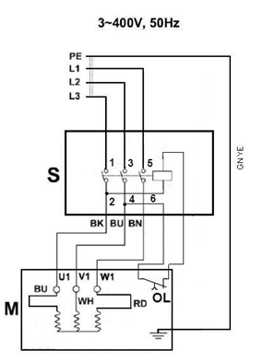
Wiring Diagram for DC-1200 Dust Collector

10001057M …………………..…..~400V, 50Hz
10001057T …………………..…...~230V, 50Hz

 | colour of strands | Litzenfarben | couleur des cordons
BK  WH  BU | Black  White  Blue | Schwarz  Weiß  Blau | Noir  blanc  Bleu
BN  YE  RD | Brown  Yellow  Red | Braun  Gelb  rot | Brun  Jaune  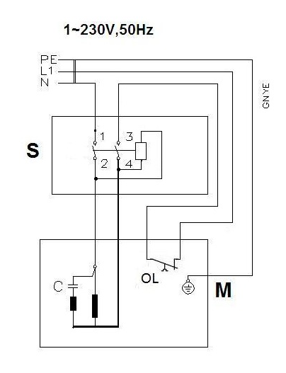  rouge
GNYE | green-yellow | grün-gelb | vert-jaune

 | meaning of symbol | Bedeutung der Zeichen | interprétation
M | motor | Motor | moteur
S | switch | Schalter | interrupteur
C  OL | Condenser  Overload cut-off | Kondensator  Überlastschutzschalter | Condensateur  Déclencheur surcharge

